Database management system lab project on

**Blood Bank Management System**

Submitted to Manipal University, Jaipur

Towards the partial fulfilment for the Award of the Degree of

# BACHELORS OF TECHNOLOGY

In Computer and Communication Engineering

2020-2024

By

Name of the Candidate

1. Shagun Singh : 209303065



Under the guidance of : Mr Jitendra Singh Yadav

Name of the Supervisor: Mr Jitendra Singh Yadav

**Department of Computer and Communication Engineering**

# School of Computing and Information Technology

**Manipal University Jaipur Jaipur, Rajasthan**

**Project Title:** Blood Bank Management System

**Registration number and Name:**

Shagun Singh- 209303065

**Introduction:**

* **Objectives/Aim:** The main objective of the project on Blood Bank Management System is to manage the details of blood bank, blood group, donor, blood stock, blood cell. It manages all the information about Blood bank, record. The project is totally built at administrative end and thus only the administrator is guaranteed the access. The purpose of the project is to build an application program to reduce the manual work for managing the “Blood Bank Management System” has been developed to override the problems prevailing in the practicing manual system. This software is supported to eliminate and, in some cases, reduce the hardships faced by this existing system. Moreover, this system is designed for the particular need of the company to carry out operations in a smooth and effective manner. Blood bank, Blood Group, Record, Donor. It tracks all the details about the donor, Blood Stock, blood cell.
* **Methodology / Planning of work:**

The model chosen to develop this project is incremental model. Incremental model included five phases which are requirement analysis, design, implementation and unit testing, integration and system testing and operation.

1. Design

This is the Second stage that used so that the flow of the project will be successful. After gather all the important information related to the project, a framework is develop to show the flow of the system so that this system flow will be easily understand. In this phase, a design of context diagram, data flow diagram (DFD) and entity relationship diagram (ERD) is used to show the flow of the system specifically.

1. Implementation

After all information has been gathered and the design has been created, we will start to develop the system to make sure that it is able to use by different user. Then, will the dietary suggestion system suggest the best diet plan for the user.

1. Testing:

At this phase, the system will be tested. If there is any error occur or detected, it must be solved at this phase and if there any changes made, it need to be re-implement back to design phase to make sure that the flow of the system is not affected.

1. Deployment:

After the system is free from error and bugs, the system will then be deployed for market. The testing that takes place will approve the validity of the system for marketing. By then, it is mandatory to monitor the system time to time to make sure that if any changes had to be done, it is noticed.

1. Conclusion:

An online blood bank management system is designed and developed successfully. The developed system proves to be more effect in terms of accessibility speed and the security. Online database aided with automatic call routing facility can is an apt choice for immediate fulfilment of blood requirements for the emergency people who suffers in different situations.

* **Technical Details (Tools/Technologies/Language):**

|  |  |  |
| --- | --- | --- |
| Number | Description | Type |
| 1 | Operating System | Windows XP / Windows |
| 2 | Language | PHP |
| 3 | Database | MySQL |
| 4 | IDE | Visual Code, Sublime text, notepad++ |
| 5 | Browser | Google Chrome |

* **Market Potential & Competitive advantages:**

There are three beneficiaries which can get benefits from the management information system of blood bank which are 1. Donors: person who wants to donate the blood voluntarily at the blood donation camp. Information system also keeps the record of the donors who wants to register online. 2. Seekers: person who wants the blood from the blood bank due to various reasons like accidents, surgeries, delivery and many more. 3. Blood bank: staff people which are working in the blood bank which includes staff member, operator, blood bank in charge, head of pathological department.

* **Motivation:**

The system is used for maintaining all the process and activities of blood bank management.

The system can be extended to be used for maintaining records of hospital, organ donation and other similar sectors. While developing the system, there shall be space for further modification.

There shall be proper documentation so that further enhancement becomes easy.

* **Write Up:**

1. Donors are identified by donor id, and their names, contact detail, date of birth, location, units of blood donated and its blood group must be recorded.
2. Patients are identified by patient id, and their name, contact detail, date of birth, location, units of blood required, blood group, and units of blood taken must be recorded.
3. There are multiple blood banks. And each office of a blood bank is identified by a id, and name, phone number, email, and location must be recorded.
4. The blood bank offices are managed by an employee that is identified by an id and has a username and a password.
5. The employee can login any number of times.
6. Blood of different blood groups in large number is stored in different blood bank’s inventory, named blood stock which is identified by blood group, and the price of blood and units of blood available is recorded.
7. Many patients can order blood from different blood banks.
8. A donor can donate blood once in different units depending upon the health of the donor.
9. Price of the blood is dependent upon the units of the blood.

* **Assumptions made:**

1. Donor donates blood to the blood bank.
2. Every unit of blood donated is stored in the blood bank.
3. Each blood bank has its inventory known as blood stock.
4. The donor does not submit any false report to his system.
5. A doctor or a patient can request for an exact blood group. But the request comes through blood bank authorities to the system admin. Therefore, doctor and patient are not direct users of the system.
6. Login page consist of username and password which is stored in database.

* **ER DIAGRAM:**

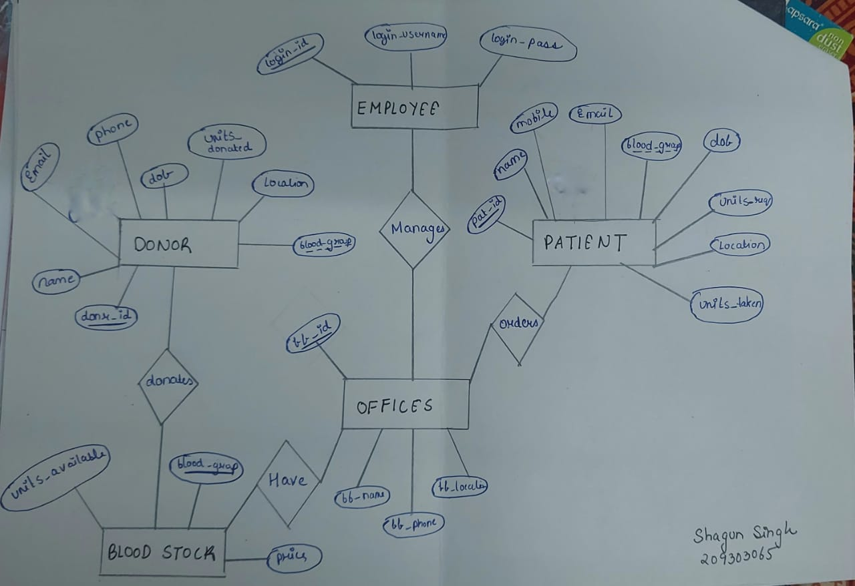

* **Relational Schema:**

DONOR(donr_id, name, mobile, email, dob, location, units_donated, blood_group)

PATIENT(pat_id, name, mobile, email, blood_group, location, dob, units_req, units_taken)

BLOOD STOCK(blood_group, units_available, price, bb_id, donr_id)

ORDERS(pat_id, bb_id)

OFFICES(bb_id, bb_name, bb_phone, bb_location, login_id)

EMPLOYEE(login_id, login_username, login_pass)

* **Normalization:**

Boyce Codd introduced a number of ‘normal forms’ (1970- 1972). They are principles

that can hold for a given relation or not.

The formal definition of Normalization is: it is the sequence of steps by which a

relational database model is both created and improved upon. The sequence of steps

involved in the normalization process is called normal forms. Essentially, normal forms

applied during a process of normalization allow creation of a relational database model as

a step-by-step progression.

**Normal Forms:**

* *First Normal Form (1NF):* A relation is in first normal form if it contains only simple,

atomic values for attributes, no sets; that is, if attributes do not have sub attributes.

* *Second Normal Form (2NF):* A relation is in second normal form, if it is in 1NF and

every non-primary key attribute is fully functionally dependent on the primary key of the

relation.

Example:

Relation :( A, B, C, D)

{A} = > {B}

{A} = > {C}

{A} = > {D}

It is in 2NF because it is in 1NF and every non-primary key attribute is fully functionally

dependent on the primary key of the relation.

* *Third Normal Form (3NF):* A relation is in third normal form, if it is in 2NF and no

non-primary key attribute is transitively dependent on the primary key.

Example:

Relation :( A, B, C, D, E )

{A, B} = > {C}

{A, B} = > {E}

This relation is in third normal form because it is in 2NF and no non-primary key

attribute is transitively dependent on the primary key.

* *Boyce-Codd Normal Form (BCNF):* A relation is in BCNF, if for every full functional

dependency X = > Y holds: X is a candidate key. If part of primary key is fully

functionally dependent on non primary key, BCNF violation occurs.

Example:

Relation :( A, B, C, D )

{A, B} = > {C, D}

{C} = > {A}

In 1NF, 2NF, 3NF, but not in BCNF. Because part of primary key, A is fully functionally

dependent on non- primary key C. We have to split the original relation.

( A, B, D ), ( C, A ).

Now in BCNF.

**Advantages of normalization:**

1. Many unnecessary redundancies are avoided.
2. Anomalies with input, deletion and updates can be avoided.
3. Fully normalized, relations tend to need less space than if not normalized.

**Disadvantages of normalization:**

1. Normalization splits entities and relationships into many relations, thus making them harder to understand.
2. Queries become more complex because they have to involve more relations.
3. Response times are longer because of a higher number of joins in the queries.

* **Normalization of Blood Bank database:**

1. **Donor (donr_id, name, mobile, email, dob, location, units_donated, blood_group)**

{donr_id} = > {} (functional dependency exists, because two different names do not

correspond to the same donr_id).

{donr_id} = > {mobile} (functional dependency exists).

{donr_id} = > {email} (functional dependency exists).

{donr_id} = > {dob} (functional dependency exists).

{donr_id} = > {location} (functional dependency exists).

{donr_id} = > {units_donated} (functional dependency exists).

{donr_id} = > {blood_group} (functional dependency exists).

The relation is in 1NF because its attributes do not have sub attributes.

The relation is in second normal form, as it is in 1NF and every non-primary key attribute

is fully functionally dependent on the primary key of the relation.

The relation is in third normal form, as it is in 2NF and no non-primary key attribute is

transitively dependent on the primary key.

No part of primary key is fully functionally dependent on non-primary key. So, the

relation is in BCNF

1. **Employee (login_id, login_username,login_pass)**

{login_id} -> {login_username} (functional dependency exists).

{login_id} -> {login_pass} (functional dependency exists).

The relation is in 1NF.

The relation is in second normal form.

The relation is in third normal form.

The relation is in BCNF.

1. **Patient(pat_id,name,mobile,email,blood_group,location,dob,units_req,units_taken)**

{pat_id} -> {name} (functional dependency exists).

{pat_id} -> {mobile} (functional dependency exists).

{pat_id} -> {email} (functional dependency exists).

{pat_id} -> {blood_group} (functional dependency exists).

{pat_id} -> {location} (functional dependency exists).

{pat_id} -> {dob} (functional dependency exists).

{pat_id} -> {units_required} (functional dependency exists).

{pat_id} -> {units_taken} (functional dependency exists).

The relation is in 1NF.

The relation is in second normal form.

The relation is in third normal form.

The relation is in BCNF**.**

1. **Blood_stock( blood_group,units_available, price,bb_id,donr_id)**

{blood_group} -> {units_available} (functional dependency exists).

{blood_group} -> {price} (functional dependency exists).

{blood_group} -> {bb_id} (functional dependency exists).

{blood_group} -> {donr_id} (functional dependency exists).

The relation is in 1NF.

The relation is in second normal form.

The relation is in third normal form.

The relation is in BCNF.

1. **Offices(bb_id, bb_name, bb_phone, bb_location, login_id)**

{bb_id} -> {name} (functional dependency exists).

{bb_id} -> {bb_phone} (functional dependency exists).

{bb_id} -> {bb_location} (functional dependency exists).

{bb_id} -> {login_id} (functional dependency exists).

The relation is in 1NF.

The relation is in second normal form.

The relation is in third normal form.

The relation is in BCNF.

* **Data dictionary**

1. Table name: Employee

|  |  |  |  |  |
| --- | --- | --- | --- | --- |
| Field name | Data types | size | constraints | Description |
| Login_id | int | 50 | Primary key | To store the user id |
| Login_username | varchar | 50 | NOT NULL | To store the username |
| Login_pass | varchar | 50 | NOT NULL | To store the password of the user. |

1. Table name : Donor

|  |  |  |  |  |
| --- | --- | --- | --- | --- |
| Field name | Data types | size | constraints | Description |
| Donr_id | int | 50 | Primary Key | To store id of the donor. |
| Name | char | 100 | NOT NULL | To store name of the donor. |
| Mobile | int | 50 | NOT NULL | To store mobile number of the donor. |
| Email | varchar | 100 | NOT NULL | To store email address of the donor. |
| Dob | date |  | NOT NULL | To store date of birth of the donor. |
| Location | varchar | 100 | NOT NULL | To store location of the donor. |
| Units_donated | int | 30 |  | To store the number of units donated. |
| Blood_group | varchar | 10 | Foreign key | Used as foreign key to establish a relationship between the blood stock and the donor. |

1. Table name: Patient

|  |  |  |  |  |
| --- | --- | --- | --- | --- |
| Field name | Data types | size | constraints | Description |
| Pat_id | int | 50 | Primary Key | To store the patient id. |
| Name | char | 100 | NOT NULL | To store the patient’s name. |
| Mobile | int | 50 | NOT NULL | To store mobile number of the patient. |
| Email | nvarchar | 1000 | NOT NULL | To store email address of the patient. |
| Blood_group | varchar | 10 | NOT NULL | To store the blood group of the patient. |
| Pat_dob | datetime |  | NOT NULL | To store date of birth of the patient. |
| Units_req | int | 30 | NOT NULL | To store the number of blood units required by the patient. |
| location | nvarchar | 100 | NOT NULL | To store location of the patient. |
| Blood_group | varchar | 10 | Foreign key | Used as foreign key to establish a relationship between the blood stock and the patient. |

1. Table name: Blood Stock

|  |  |  |  |  |
| --- | --- | --- | --- | --- |
| Field name | Data types | size | constraints | Description |
| Blood_group | varchar | 10 | Primary key | To store the blood group of blood stored in blood bank. |
| Units_available | int | 30 | NOT NULL | To store the number of units of blood in blood bank |
| price | int | 50 | NOT NULL | To store the price of blood per unit. |

1. Table name : Offices

|  |  |  |  |  |
| --- | --- | --- | --- | --- |
| Field name | Data types | size | constraints | Description |
| Bb_id | int | 50 | Primary key | To store the blood bank id. |
| Bb_name | char | 100 | NOT NULL | To store the name of the blood bank. |
| Bb_phone | int | 50 | NOT NULL | To store the phone number of the blood bank. |
| Bb_location | varchar | 100 | NOT NULL | to store the location of the blood bank. |

**Screenshot of frontend:**

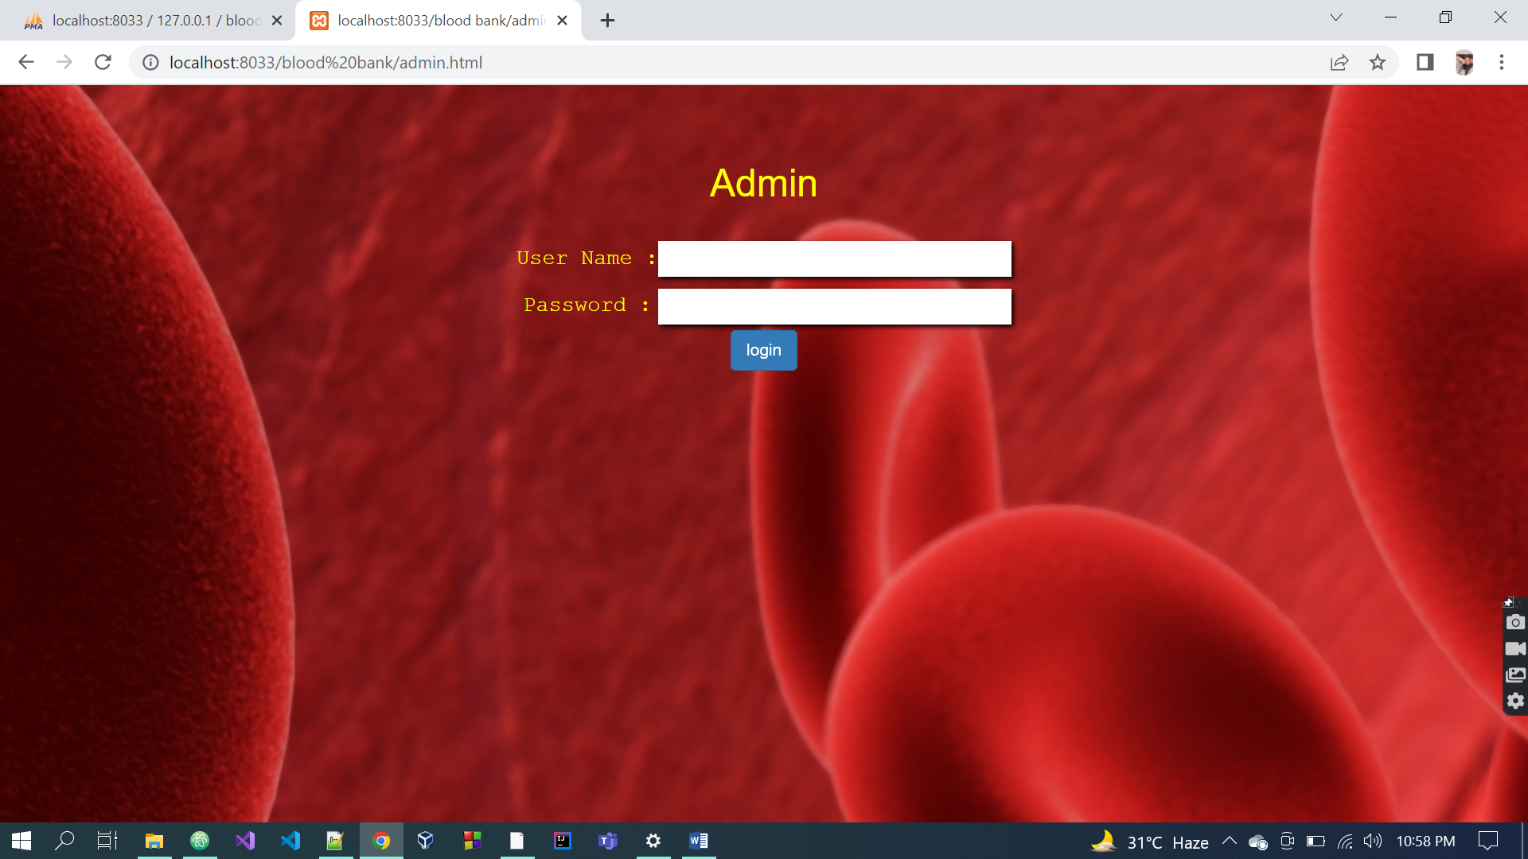

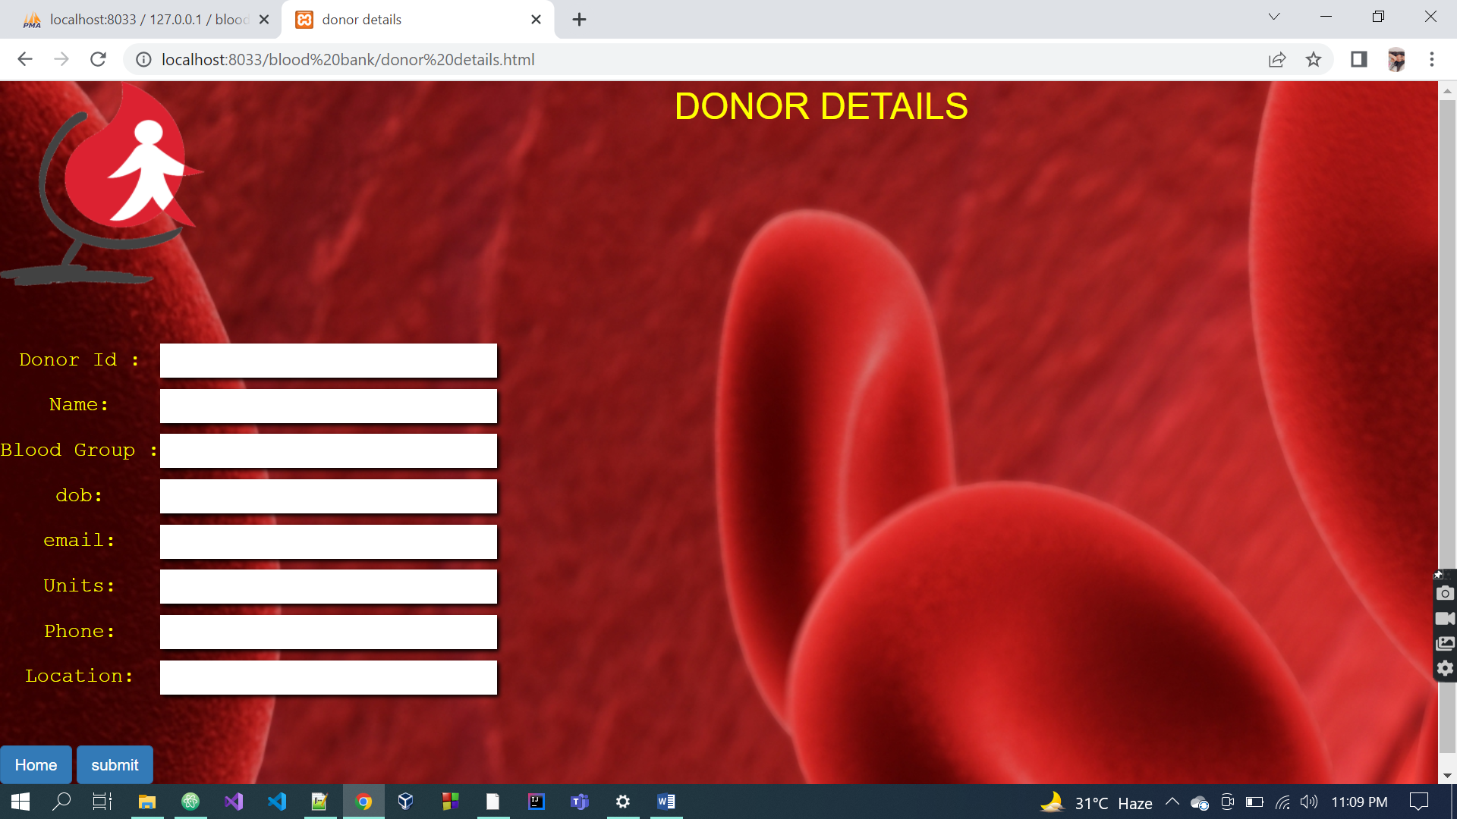

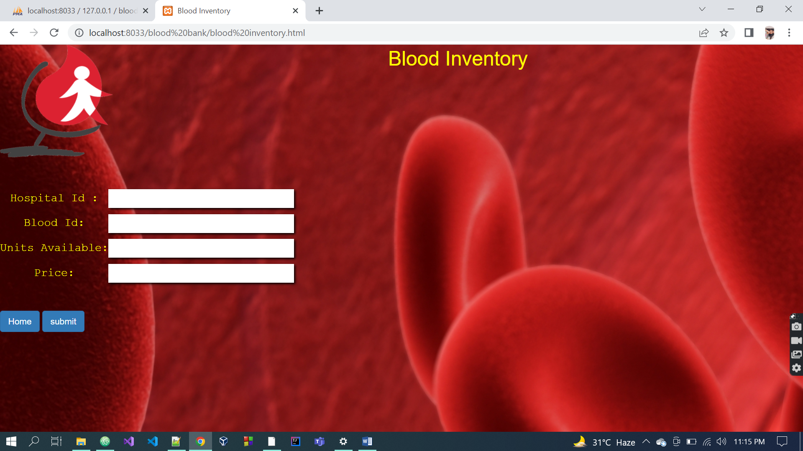

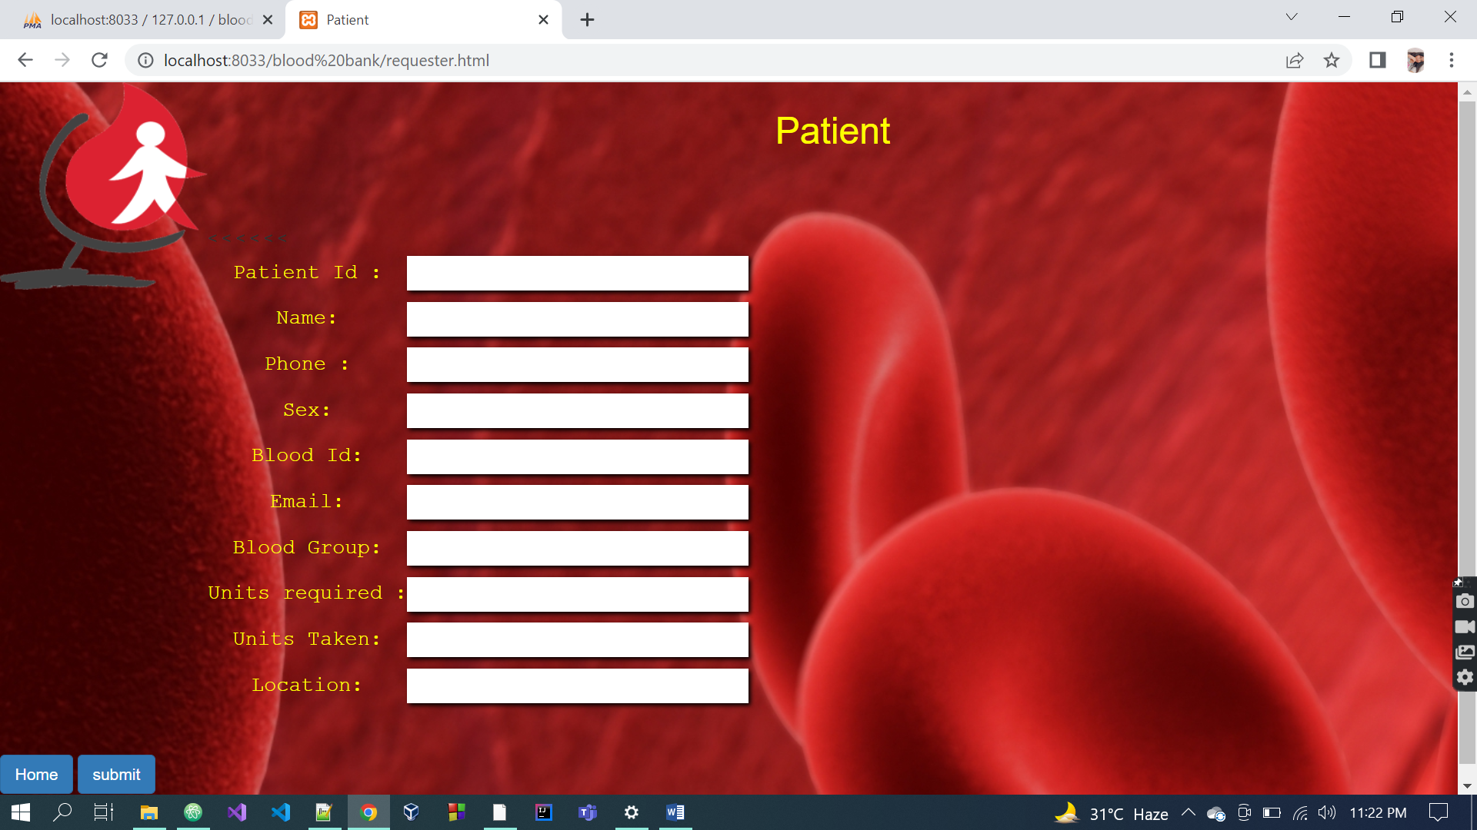

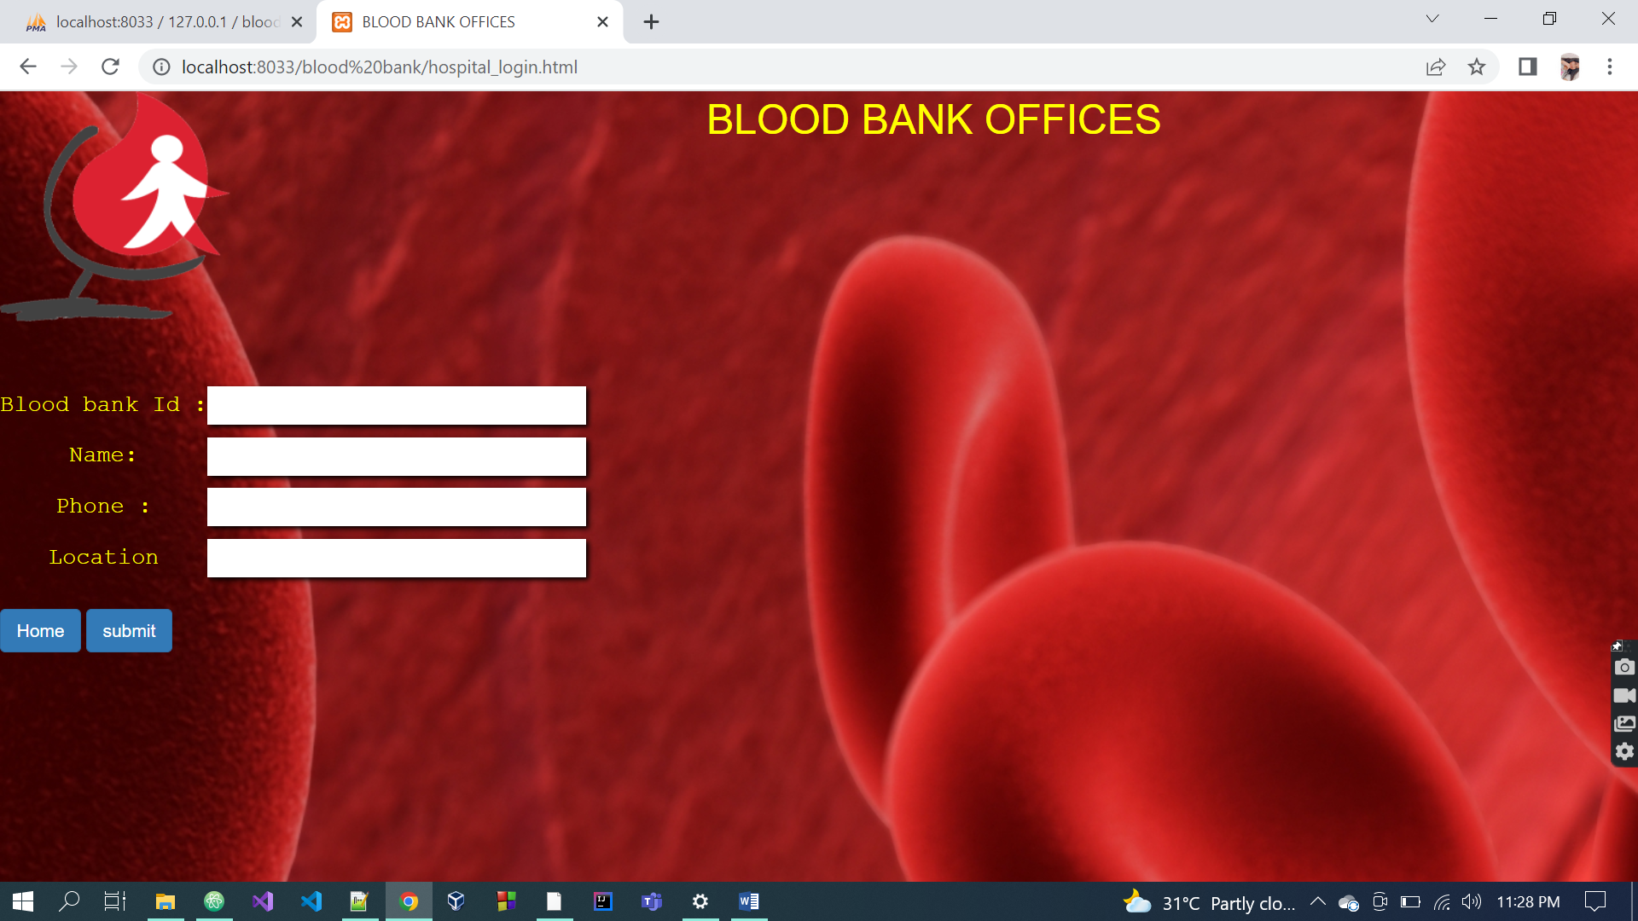

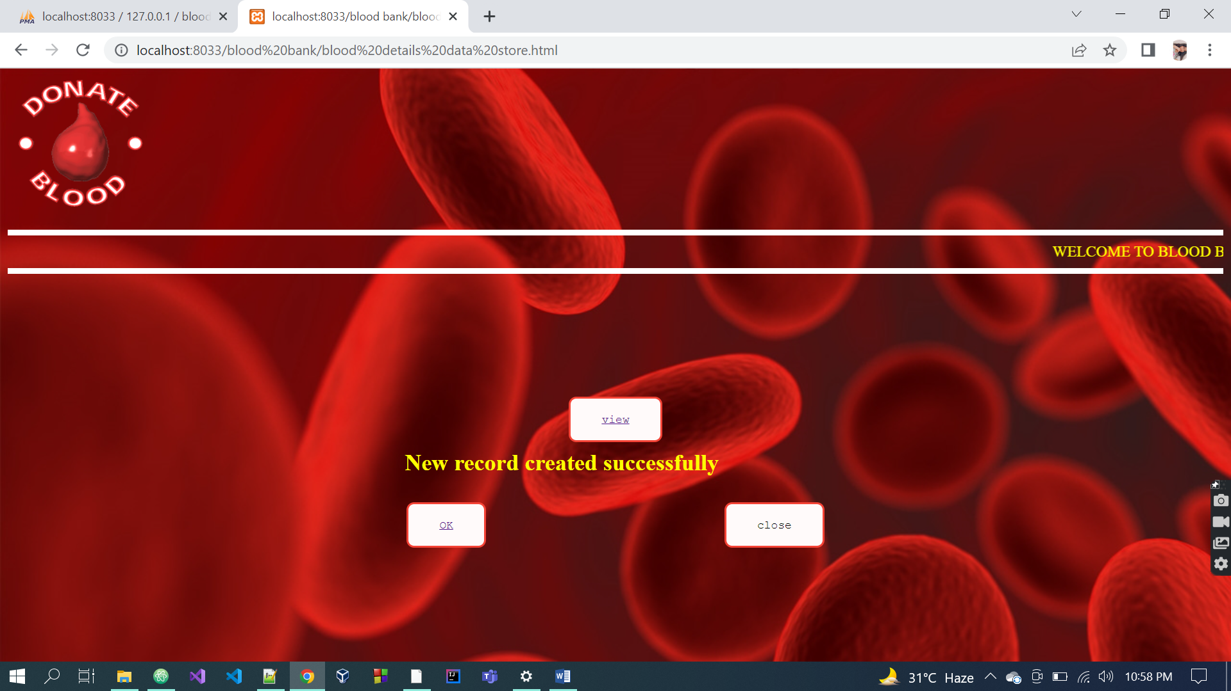

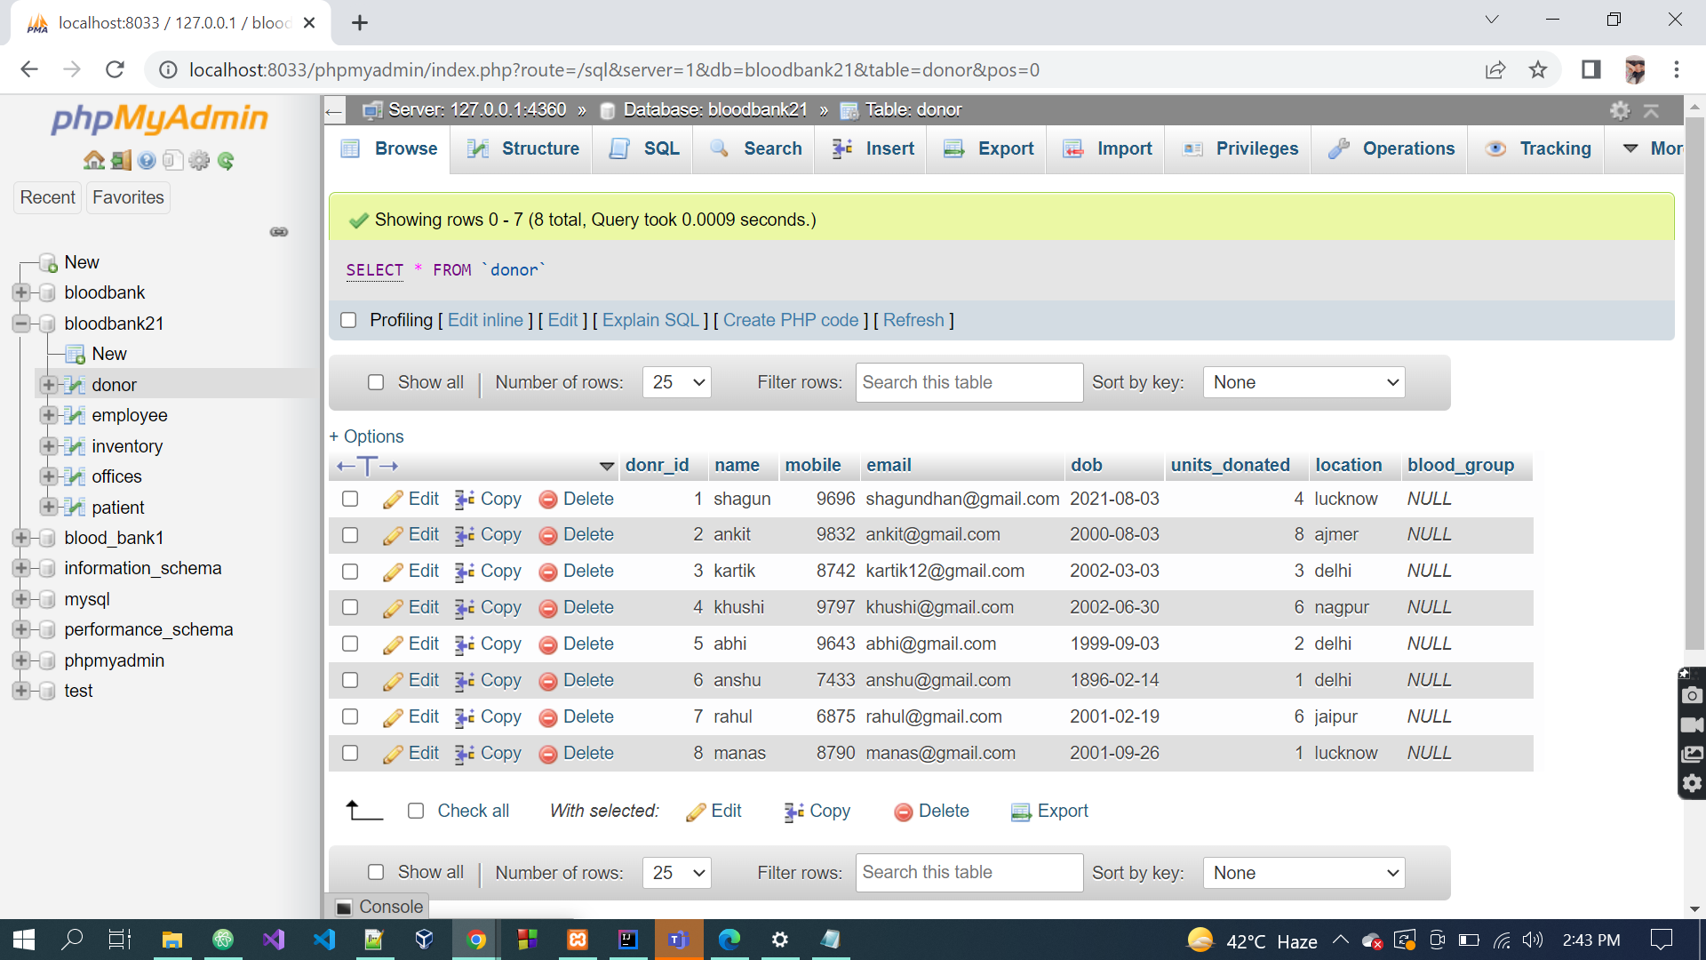

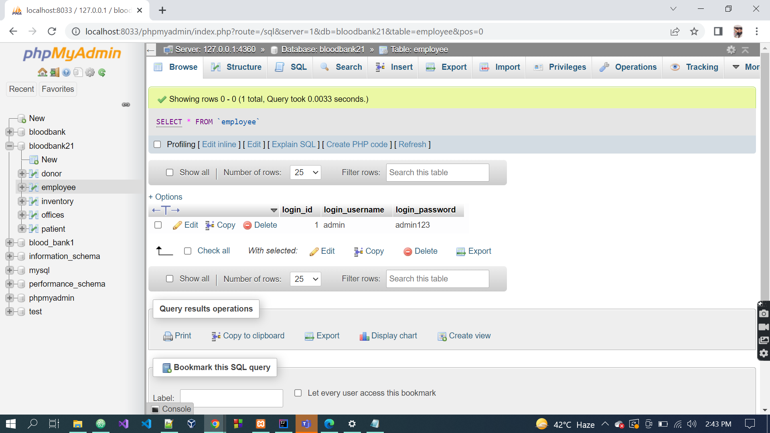

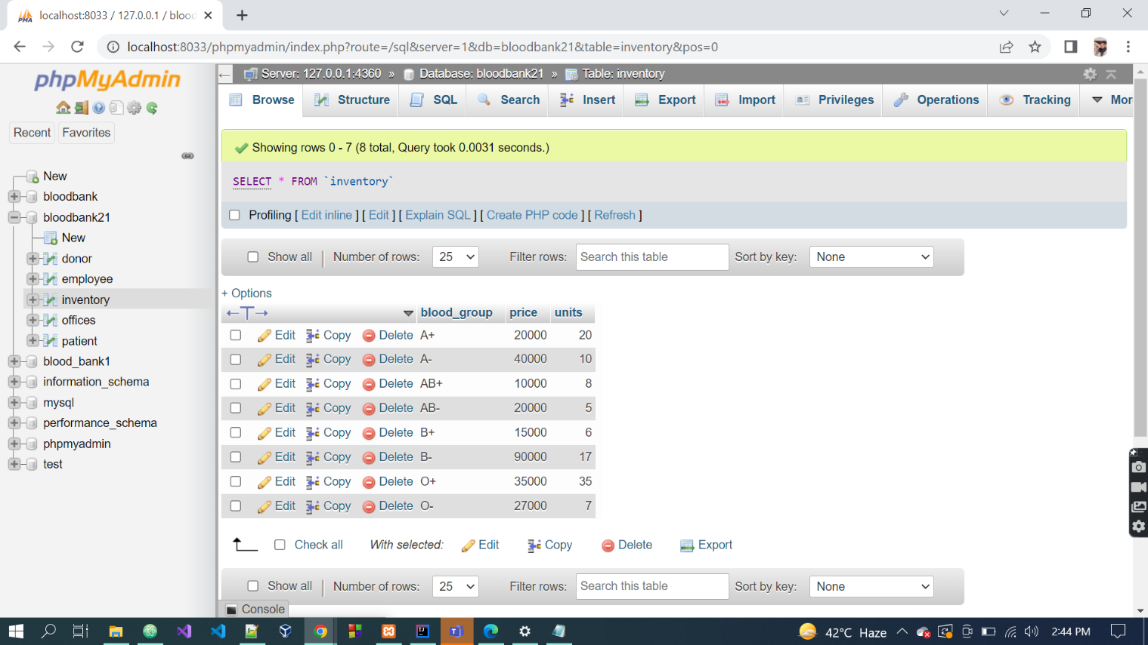

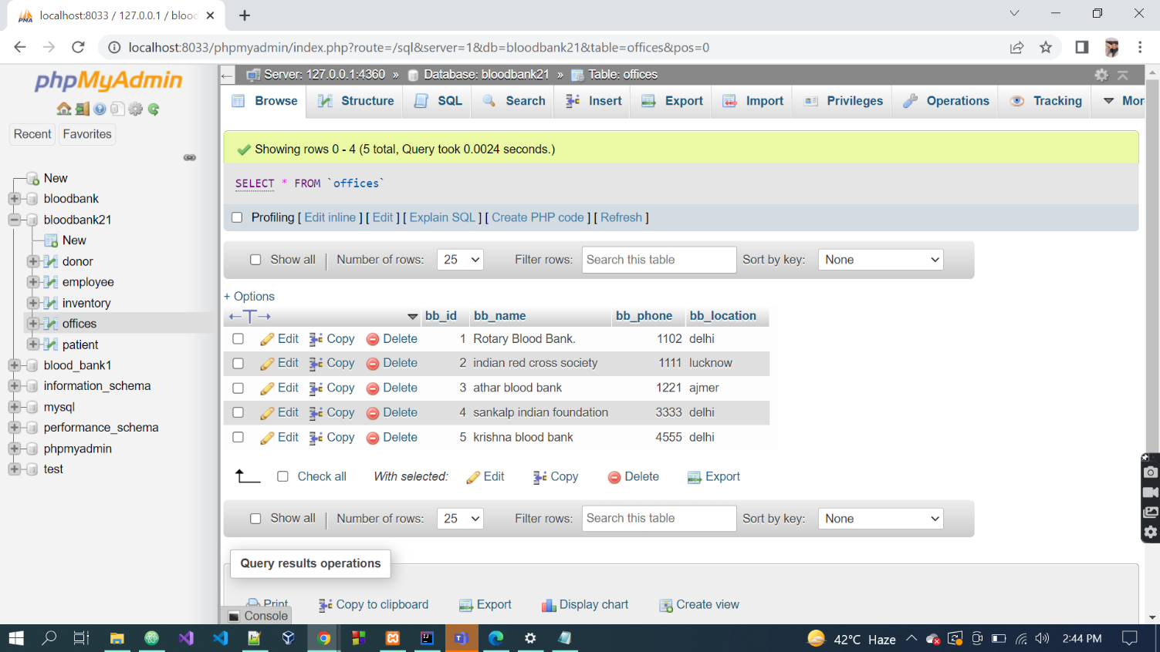

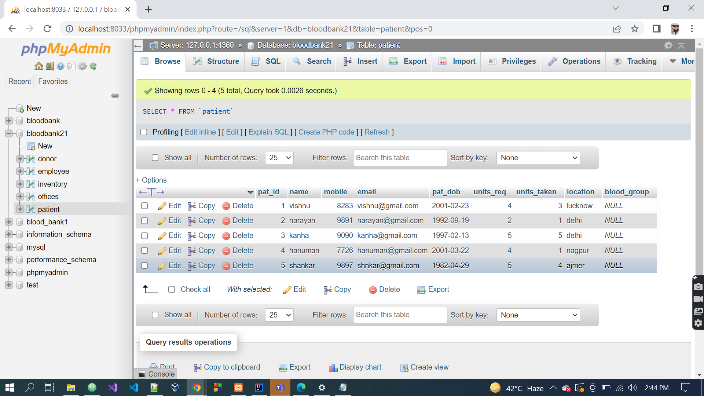

**Source code:**

1. ***Blood_details.html***

<html>

<head>

<link rel="stylesheet" type="text/css" href="bootstrap.css">

<style>

input{

font-size: x-large;

box-shadow: 2px 2px 4px black;

border:none;

}

</style>

<title>Blood Details</title>

</head>

<body background="b.jpg">

<img src="5.gif" alt="Flowers in Chania" style="float:left" width="180" height="180">

<form action="blood details.php" method="POST">

<center><font size="6"><font color="yellow">Blood Details</font></font></center>

<table>

<br>

<br>

<br>

<br>

<br>

<br>

<br>

<br><br>

<tr>

<td><font style="font-family:courier;"><font size="5"><font color="yellow"><h4 style="text-align:center;">Blood Id :</h4></font></font></font></td>

<td><input type="number" name="blood_id" required></td>

</tr>

<tr>

<td><font style="font-family:courier;"><font size="5"><font color="yellow"><h4 style="text-align:center;"> Blood Group:</h4></font></font></font></td>

<td><input type="text" name="blood_group" required></td>

</tr>

</table><br><br>

<tr>

<a href="admin1.html" class="btn btn-primary" >Home</a>

<button type="submit" value="Submit" class="btn btn-primary" >submit</button><br>

</tr>

</form>

</body>

</html>

1. **Blood_detail.php**

<html>

<body>

<?php

// define variables and set to empty values

$nameErr = $blood_idErr = $blood_groupErr = "";

$name = $blood_id = $blood_group = "";

$name1 = $blood_id1 = $blood_group1 = "";

///////id start

if ($_SERVER["REQUEST_METHOD"] == "POST") {

if (empty($_POST["blood_id"])) {

$blood_idErr = "blood_id is required";

} else {

$blood_id = test_input($_POST["blood_id"]);

// check if name only contains letters and whitespace

if (!preg_match("/^[ 0-9 ]*$/",$blood_id)) {

$blood_idErr = "Only numbers and white space allowed";

}else

$blood_id1 = $_POST["blood_id"];

}echo "<br>";

/// id over

///name start

if (empty($_POST["blood_group"])) {

$blood_groupErr = "blood_group is required";

} else {

$blood_group = test_input($_POST["blood_group"]);

// check if name only contains letters and whitespace

if (!preg_match("/^[ a-z A-Z + - ]*$/",$blood_group)) {

$blood_groupErr = "Only letters and white space allowed";

}else

$blood_group1 = $_POST["blood_group"];

}echo "<br>";

/// name over

}

function test_input($data) {

$data = trim($data);

$data = stripslashes($data);

$data = htmlspecialchars($data);

return $data;

}

////connection

$servername = "localhost";

$username = "root";

$password = "";

$dbname = "blood_bank1";

// Create connection

$conn = new mysqli($servername, $username, $password, $dbname);

// Check connection

if ($conn->connect_error) {

die("Connection failed: " . $conn->connect_error);

}

////

$sql = "INSERT INTO blood_details

VALUES ($blood_id1,'$blood_group1')";

if ($conn->query($sql) === TRUE) {

include 'blood details data store.html';

} else {

echo "Error: " . $sql . "<br>" . $conn->error;

}

$conn->close()

?>

</body>

</html>

1. ***Blood_inventory.html***

<html>

<head>

<link rel="stylesheet" type="text/css" href="bootstrap.css">

<style>

input{

font-size: x-large;

box-shadow: 2px 2px 4px black;

border:none;

}

</style>

<title>Blood Inventory</title>

</head>

<body background="b.jpg">

<img src="5.gif" alt="Flowers in Chania" style="float:left" width="180" height="180">

<form action="blood inventory.php" method="POST">

<center><font size="6"><font color="yellow">Blood Inventory</font></font></center>

<table>

<br>

<br>

<br>

<br>

<br>

<br>

<br>

<br>

<br>

<tr>

<td><font style="font-family:courier;"><font size="5"><font color="yellow"><h4 style="text-align:center;">Hospital Id :</h4></font></font></font></td>

<td><input type="number" name="hospital_id" required></td>

</tr>

<tr>

<td><font style="font-family:courier;"><font size="5"><font color="yellow"><h4 style="text-align:center;"> Blood Id:</h4></font></font></font></td>

<td><input type="number" name="blood_id" required></td>

</tr>

<tr>

<td><font style="font-family:courier;"><font size="5"><font color="yellow"><h4 style="text-align:center;"> Units Available:</h4></font></font></font></td>

<td><input type="number" name="Units_Available" required></td>

</tr>

<tr>

<td><font style="font-family:courier;"><font size="5"><font color="yellow"><h4 style="text-align:center;"> Price:</h4></font></font></font></td>

<td><input type="number" name="Price" required></td>

</tr>

</table><br><br>

<tr>

<a href="admin1.html" class="btn btn-primary" >Home</a>

<button type="submit" value="Submit" class="btn btn-primary">submit</button>

</tr>

</form>

</body>

</html>

1. **Blood_inventory.php**

<html>

<body>

<?php

// define variables and set to empty values

$nameErr = $hospital_idErr = $blood_idErr = $qtyErr = "";

$name = $hospital_id = $blood_id = $qty = "";

$name1 = $hospital_id1 = $blood_id1 = $qty1 = "";

///////hospital_id start

if ($_SERVER["REQUEST_METHOD"] == "POST") {

if (empty($_POST["hospital_id"])) {

$hospital_idErr = "hospital_id is required";

} else {

$hospital_id = test_input($_POST["hospital_id"]);

// check if name only contains letters and whitespace

if (!preg_match("/^[ 0-9 ]*$/",$hospital_id)) {

$hospital_idErr = "Only numbers are allowed";

}else

$hospital_id1 = $_POST["hospital_id"];

}echo "<br>";

///hospital_id over

///blood_id start

if (empty($_POST["blood_id"])) {

$blood_idErr = "blood_id is required";

} else {

$blood_id = test_input($_POST["blood_id"]);

// check if name only contains letters and whitespace

if (!preg_match("/^[ 0-9 ]*$/",$blood_id)) {

$blood_idErr = "Only numbers and are allowed";

}else

$blood_id1 = $_POST["blood_id"];

}echo "<br>";

/// blood_id over

/// qty start

if (empty($_POST["qty"])) {

$qtyErr = "quantity is required";

} else {

$qty = test_input($_POST["qty"]);

// check if phone contains only contains letters

$qty1 = $_POST["qty"];

if (!preg_match("/^[ 0-9 ]*$/",$qty)) {

$qtyErr = "Only numbers allowed";

}else

$qty = $_POST["qty"];

}

echo "<br>";

/// qty is over

}

function test_input($data) {

$data = trim($data);

$data = stripslashes($data);

$data = htmlspecialchars($data);

return $data;

}

////connection

$servername = "localhost:8033";

$username = "root";

$password = "";

$dbname = "blood_bank1";

// Create connection

$conn = new mysqli($servername, $username, $password, $dbname);

// Check connection

if ($conn->connect_error) {

die("Connection failed: " . $conn->connect_error);

}

////

$sql = "INSERT INTO blood_inventory

VALUES ($hospital_id1,$blood_id1,$qty1)";

if ($conn->query($sql) === TRUE) {

include 'blood inventory data store.html';

} else {

echo "Error: " . $sql . "<br>" . $conn->error;

}

$conn->close()

?>

</body>

</html>

1. **Donor_detail.html**

<html>

<head>

<link rel="stylesheet" type="text/css" href="bootstrap.css">

<style>

input{

font-size: x-large;

box-shadow: 2px 2px 4px black;

border:none;

}

</style>

<title>donor details</title>

</head>

<body background="b.jpg">

<img src="5.gif" alt="Flowers in Chania" style="float:left" width="180" height="180">

<form action="donor details.php" method="POST">

<center><font size="6"><font color="yellow">DONOR DETAILS</font></font></center>

<table>

<br>

<br>

<br>

<br>

<br>

<br>

<br>

<br>

<br>

<tr>

<td><font style="font-family:courier;"><font size="5"><font color="yellow"><h4 style="text-align:center;">Donor Id :</h4></font></font></font></td>

<td><input type="number" name="donor_id" required></td>

</tr>

<tr>

<td><font style="font-family:courier;"><font size="5"><font color="yellow"><h4 style="text-align:center;"> Name:</h4></font></font></font></td>

<td><input type="text" name="name" required></td>

</tr>

<tr>

<td><font style="font-family:courier;"><font size="5"><font color="yellow"><h4 style="text-align:center;">Blood Group :</h4></font></font></font></td>

<td><input type="text" name="blood_group" required></td>

</tr>

<tr>

<td><font style="font-family:courier;"><font size="5"><font color="yellow"><h4 style="text-align:center;">dob:</h4></font></font></font></td>

<td><input type="number" name="dob" required></td>

</tr>

<tr>

<td><font style="font-family:courier;"><font size="5"><font color="yellow"><h4 style="text-align:center;">email:</h4></font></font></font></td>

<td><input type="text" name="email" required></td>

</tr>

<tr>

<td><font style="font-family:courier;"><font size="5"><font color="yellow"><h4 style="text-align:center;">Units:</h4></font></font></font></td>

<td><input type="number" name="Units_Donated" required></td>

</tr>

<tr>

<td><font style="font-family:courier;"><font size="5"><font color="yellow"><h4 style="text-align:center;">Phone:</h4></font></font></font></td>

<td><input type="number" name="phn" required></td>

</tr>

<tr>

<td><font style="font-family:courier;"><font size="5"><font color="yellow"><h4 style="text-align:center;"> Location:</h4></font></font></font></td>

<td><input type="text" name="Location" required></td>

</tr>

</table><br><br>

<tr>

<a href="admin1.html" class="btn btn-primary">Home</a>

<button type="submit" value="Submit" class="btn btn-primary" >submit</button>

</tr>

</form>

</body>

</html>

1. ***Donor_detail.php***

<html>

<body>

<?php

// define variables and set to empty values

$nameErr =$donor_idErr = $nameErr = $blood_groupErr = $ageErr = $phnErr = "";

$name = $donor_id = $name = $blood_group = $age = $phn = "";

$name1 = $donor_id1 = $name1 = $blood_group1 = $age1 = $phn1 ="";

///////donor_id start

if ($_SERVER["REQUEST_METHOD"] == "POST") {

if (empty($_POST["donor_id"])) {

$donor_idErr = "donor_id is required";

} else {

$donor_id = test_input($_POST["donor_id"]);

// check if name only contains letters and whitespace

if (!preg_match("/^[0-9 ]*$/",$donor_id)) {

$nameErr = "Only number and white space allowed";

}else

$donor_id1 = $_POST["donor_id"];

}echo "<br>";

/// donor_id over

///name start

if (empty($_POST["name"])) {

$nameErr = "name is required";

} else {

$name = test_input($_POST["name"]);

// check if name only contains letters and whitespace

if (!preg_match("/^[a-zA-Z ]*$/",$name)) {

$nameErr = "Only letters and white space allowed";

}else

$name1 = $_POST["name"];

}echo "<br>";

/// name over

/// blood group start

if (empty($_POST["blood_group"])) {

$blood_groupErr = "Blood_group is required";

} else {

$blood_group = test_input($_POST["blood_group"]);

// check if blood_group contains only contains letters

$blood_group1 = $_POST["blood_group"];

if (!preg_match("/^[a-zA-Z+-]*$/",$blood_group)) {

$blood_groupErr = "Only letters and operators allowed";

}else

$blood_group = $_POST["blood_group"];

}

echo "<br>";

/// blood_groupis over

/// age start

if (empty($_POST["age"])) {

$ageErr = "age is required";

} else {

$age = test_input($_POST["age"]);

// check if name only contains letters and whitespace

if (!preg_match("/^[0-9 ]*$/",$age)) {

$ageErr = "Only numbers and white space allowed";

}

else $age1= $_POST["age"];

}

echo "<br>";

/// age end

////start phone

if (empty($_POST["phn"])) {

$phnErr = "phone no is required";

} else {

$phn = test_input($_POST["phn"]);

// check if name only contains letters and whitespace

if (!preg_match("/^[0-9 ]*$/",$phn)) {

$phnErr = "Only numbers and white space allowed";

}

else $phn1= $_POST["phn"];

}

echo "<br>";

}

function test_input($data) {

$data = trim($data);

$data = stripslashes($data);

$data = htmlspecialchars($data);

return $data;

}

////connection

$servername = "localhost:8033";

$username = "root";

$password = "";

$dbname = "blood_bank1";

// Create connection

$conn = new mysqli($servername, $username, $password, $dbname);

// Check connection

if ($conn->connect_error) {

die("Connection failed: " . $conn->connect_error);

}

////

$sql = "INSERT INTO donar_details

VALUES ($donor_id1,'$name1','$blood_group1',$age1,$phn1)";

if ($conn->query($sql) === TRUE) {

include 'disptri.php';

} else {

echo "Error: " . $sql . "<br>" . $conn->error;

}

$conn->close()

?>

</body>

</html>

1. ***Hospital_login.html***

<html>

<head>

<link rel="stylesheet" type="text/css" href="bootstrap.css">

<style>

input{

font-size: x-large;

box-shadow: 2px 2px 4px black;

border:none;

}

</style>

<title>BLOOD BANK OFFICES</title>

</head>

<body background="b.jpg">

<img src="5.gif" alt="Flowers in Chania" style="float:left" width="180" height="180">

<form action="hospital_login.php" method="POST">

<center><font size="6"><font color="yellow">BLOOD BANK OFFICES</font></font></center>

<table>

<br>

<br>

<br>

<br>

<br>

<br>

<br>

<br>

<br>

<tr>

<td><font style="font-family:courier;"><font size="5"><font color="yellow"><h4 style="text-align:center;">Blood bank Id :</h4></font></font></font></td>

<td><input type="number" name="bb_id" required></td>

</tr>

<tr>

<td><font style="font-family:courier;"><font size="5"><font color="yellow"><h4 style="text-align:center;"> Name:</h4></font></font></font></td>

<td><input type="text" name="bb_name" required></td>

</tr>

<tr>

<td><font style="font-family:courier;"><font size="5"><font color="yellow"><h4 style="text-align:center;">Phone :</h4></font></font></font></td>

<td><input type="password" name="bb_phone" required></td>

</tr>

<tr>

<td><font style="font-family:courier;"><font size="5"><font color="yellow"><h4 style="text-align:center;">Location</h4></font></font></font></td>

<td><input type="number" name="location" required></td>

</tr>

</table><br>

<tr>

<a href="admin1.html" class="btn btn-primary" >Home</a>

<button type="submit" value="Submit" class="btn btn-primary" >submit</button>

</tr>

</form>

</body>

</html>

1. ***Hospital_login.php***

<html>

<body>

<?php

// define variables and set to empty values

$nameErr =$hospital_idErr = $user_nameErr = $passwordErr = $donor_idErr = "";

$name = $hospital_id = $user_name = $password = $donor_id = "";

$name1 = $hospital_id1 = $user_name1 = $password1 = $donor_id1 ="";

///////hospital_id start

if ($_SERVER["REQUEST_METHOD"] == "POST") {

if (empty($_POST["hospital_id"])) {

$donor_idErr = "hospital_id is required";

} else {

$hospital_id = test_input($_POST["hospital_id"]);

// check if name only contains letters and whitespace

if (!preg_match("/^[0-9 ]*$/",$hospital_id)) {

$nameErr = "Only number and white space allowed";

}else

$hospital_id1 = $_POST["hospital_id"];

}echo "<br>";

/// hospital_id over

///user_name start

if (empty($_POST["user_name"])) {

$user_nameErr = "name is required";

} else {

$user_name = test_input($_POST["user_name"]);

// check if name only contains letters and whitespace

if (!preg_match("/^[a-zA-Z ]*$/",$user_name)) {

$user_nameErr = "Only letters and white space allowed";

}else

$user_name1 = $_POST["user_name"];

}echo "<br>";

/// user_name over

/// password start

if (empty($_POST["password"])) {

$passwordErr = "password is required";

} else {

$password = test_input($_POST["password"]);

// check if password contains only contains letters

$password1 = $_POST["password"];

if (!preg_match("/^[a-zA-Z]*$/",$password)) {

$passwordErr = "Only letters allowed";

}else

$password = $_POST["password"];

}

echo "<br>";

/// passwordis over

/// donor_id start

if (empty($_POST["donor_id"])) {

$donor_idErr = "donor_id is required";

} else {

$donor_id = test_input($_POST["donor_id"]);

// check if name only contains letters and whitespace

if (!preg_match("/^[0-9 ]*$/",$donor_id)) {

$donor_idErr = "Only numbers and white space allowed";

}

else $donor_id1= $_POST["donor_id"];

}

echo "<br>";

/// donor_id end

}

function test_input($data) {

$data = trim($data);

$data = stripslashes($data);

$data = htmlspecialchars($data);

return $data;

}

////connection

$servername = "localhost:8033";

$username = "root";

$password = "";

$dbname = "blood_bank1";

// Create connection

$conn = new mysqli($servername, $username, $password, $dbname);

// Check connection

if ($conn->connect_error) {

die("Connection failed: " . $conn->connect_error);

}

////

$sql = "INSERT INTO hospital_login

VALUES ($hospital_id1,'$user_name1','$password1',$donor_id1)";

if ($conn->query($sql) === TRUE) {

include 'hospital_login data store.html';

} else {

echo "Error: " . $sql . "<br>" . $conn->error;

}

$conn->close()

?>

</body>

</html>

1. ***Patient.html***

<html>

<head>

<link rel="stylesheet" type="text/css" href="bootstrap.css">

<style>

input{

font-size: x-large;

box-shadow: 2px 2px 4px black;

border:none;

}

</style>

<title>Patient</title>

</head>

<body background="b.jpg">

<img src="5.gif" alt="Flowers in Chania" style="float:left" width="180" height="180">

<form action="requester.php" method="POST">

<br />

<center><font size="6"><font color="yellow">Patient</font></font></center>

<table>

<br>

<br>

<br>

<tr>

<td><font style="font-family:courier;"><font size="5"><font color="yellow"><h4 style="text-align:center;">Patient Id :</h4></font></font></td>

<td><input type="text" name="id" required></td>

</tr>

<tr>

<td><font style="font-family:courier;"><font size="5"><font color="yellow"><h4 style="text-align:center;"> Name:</h4></font></font></td>

<td><input type="text" name="name" required></td>

</tr>

<tr>

<td><font style="font-family:courier;"><font size="5"><font color="yellow"><h4 style="text-align:center;">Phone :</h4></font></font></td>

<td><input type="number" name="phone" required></td>

</tr>

<tr>

<td><font style="font-family:courier;"><font size="5"><font color="yellow"><h4 style="text-align:center;">Sex:</h4></font></font></td>

<td><input type="text" name="donor_id" required></td>

</tr>

<tr>

<td><font style="font-family:courier;"><font size="5"><font color="yellow"><h4 style="text-align:center;">Blood Id:</h4></font></td>

<td><input type="integer" name="blood_id" required></td>

< </tr>

<tr>

<td><font style="font-family:courier;"><font size="5"><font color="yellow"><h4 style="text-align:center;">Email:</h4></font></td>

<td><input type="text" name="email" required></td>

< </tr>

<tr>

<td><font style="font-family:courier;"><font size="5"><font color="yellow"><h4 style="text-align:center;">Blood Group:</h4></font></td>

<td><input type="text" name="blood_group" required></td>

< </tr> <tr>

<td><font style="font-family:courier;"><font size="5"><font color="yellow"><h4 style="text-align:center;">Units required :</h4></font></td>

<td><input type="integer" name="Units_required" required></td>

< </tr>

<tr>

<td><font style="font-family:courier;"><font size="5"><font color="yellow"><h4 style="text-align:center;">Units Taken:</h4></font></td>

<td><input type="integer" name="units_taken" required></td>

< </tr>

<tr>

<td><font style="font-family:courier;"><font size="5"><font color="yellow"><h4 style="text-align:center;">Location:</h4></font></td>

<td><input type="integer" name="location" required></td>

< </tr>

</td></tr>

</table><br><br>

<tr>

<a href="admin1.html" class="btn btn-primary" >Home</a>

<button type="submit" value="Submit" class="btn btn-primary" >submit</button>

</tr>

</form>

</body>

</html>

1. ***Patient.php***

<html>

<body>

<?php

// define variables and set to empty values

$nameErr = $idErr = $nameErr = $phoneErr = $sexErr = $blood_idErr = "";

$name = $id = $name = $phone = $sex = $blood_id = "";

$name1 = $id1 = $name1 = $phone1 = $sex1 = $blood_id1 = "";

///////id start

if ($_SERVER["REQUEST_METHOD"] == "POST") {

if (empty($_POST["id"])) {

$donor_idErr = "id is required";

} else {

$id = test_input($_POST["id"]);

// check if name only contains letters and whitespace

if (!preg_match("/^[ 0-9 ]*$/",$id)) {

$nameErr = "Only numbers are allowed";

}else

$id1 = $_POST["id"];

}echo "<br>";

/// id over

///name start

if (empty($_POST["name"])) {

$nameErr = "name is required";

} else {

$name = test_input($_POST["name"]);

// check if name only contains letters and whitespace

if (!preg_match("/^[a-z A-Z ]*$/",$name)) {

$nameErr = "Only letters and white space allowed";

}else

$name1 = $_POST["name"];

}echo "<br>";

/// name over

/// phone start

if (empty($_POST["phone"])) {

$phoneErr = "phone is required";

} else {

$phone = test_input($_POST["phone"]);

// check if phone contains only contains letters

$phone1 = $_POST["phone"];

if (!preg_match("/^[ 0-9 ]*$/",$phone)) {

$phoneErr = "Only numbers allowed";

}else

$phone = $_POST["phone"];

}

echo "<br>";

/// phoneis over

/// sex start

if (empty($_POST["sex"])) {

$sexErr = "sex is required";

} else {

$sex = test_input($_POST["sex"]);

// check if name only contains letters and whitespace

if (!preg_match("/^[ a-z A-Z ]*$/",$sex)) {

$sexErr = "Only alphabets and white space allowed";

}

else $sex1= $_POST["sex"];

}

echo "<br>";

/// sex end

/// blood id start

if (empty($_POST["blood_id"])) {

$blood_idErr = "blood_id is required";

} else {

$blood_id = test_input($_POST["blood_id"]);

// check if name only contains letters and whitespace

if (!preg_match("/^[ 0-9 ]*$/",$blood_id)) {

$blood_idErr = "Only numbers and white space allowed";

}

else $blood_id1= $_POST["blood_id"];

}

echo "<br>";

/// blood_id end

}

function test_input($data) {

$data = trim($data);

$data = stripslashes($data);

$data = htmlspecialchars($data);

return $data;

}

////connection

$servername = "localhost:8033";

$username = "root";

$password = "";

$dbname = "blood_bank1";

// Create connection

$conn = new mysqli($servername, $username, $password, $dbname);

// Check connection

if ($conn->connect_error) {

die("Connection failed: " . $conn->connect_error);

}

////

$sql = "INSERT INTO requestor

VALUES ('$id1','$name1',$phone1,'$sex1',$blood_id)";

if ($conn->query($sql) === TRUE) {

include 'requestor data store.html';

} else {

echo "Error: " . $sql . "<br>" . $conn->error;

}

$conn->close()

?>

</body>

</html>

**Conclusion**

With the theoretical inclination of our syllabus it becomes very essential to take the atmost advantage of any opportunity of gaining practical experience that comes along. The building blocks of this Major Project ”BLOOD BANK Management System” was one of these opportunities. It gave us the requisite practical knowledge to supplement the already taught theoretical concepts thus making us more competent as a computer engineer. The project from a personal point of view also helped us in understanding the following aspects of project development:

* The planning that goes into implementing a project.
* The importance of proper planning and an organized methodology.
* The key element of team spirit and co-ordination in a successful project.

The project also provided us the opportunity of interacting with our teachers and to gain from their best experience

**Bibliography / References:**

* https://www.tutorialspoint.com/index.htm
* https://www.javatpoint.com
* https://www.w3schools.com
* https://html.com